Help for Microbes

This document contains the basic information to help you use Microbes, the Microscopic Life Simulator.

Contents:

Start up problems

Basic Controls

What is who?

Start up problems

View the ReadMe file in the “docs” folder.

Basic Controls
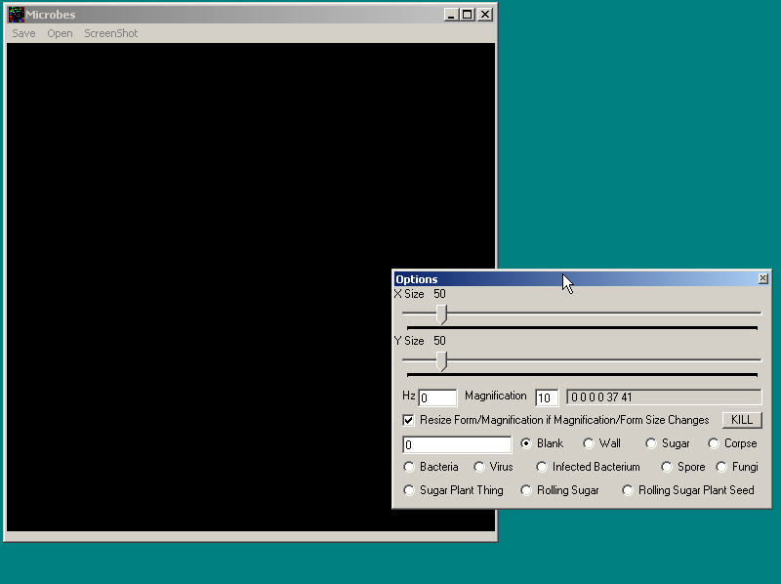
Horizontal size
Vertical size
Attempted round per second
Magnification
Synchronise magnification with display window size
How much to place
What to place
Kills the selected type
Right clicking on display window displays the values of a square: amount and type. There will be 2 each (Something may be wrong if they are not equal)! + Any click displays co-ordinates.
Minimize

Left clicking on the display window will modify the square you clicked with the settings in the option box.

Save: Saves to unique .msf file or .*
Open: Opens .msf or .*
ScreenShot: Saves display to a bitmap

What is who

Sugar Plant
Sugar
Rolling Sugar
Rolling SP Seed
Bacteria
Fungus
Virus
Infected Bacteria
Spore
Corpse
Wall
Blank

Sugar Plant:
Creates rolling sugar
Creates rolling sugar plant seeds
Can get choked if fully surrounded
Dies buy choking or time
Sugar:
Does not react to anything
Food for others
Depleats to blank space
Rolling Sugar:
Rolls for 10 rounds before forming 10000 Sugar
Rolling Sugar Plant Seed:
Rolls for 10 rounds before forming a new Sugar Plant
Spore:
Drifts for 100 rounds
Combines with food to form a fungus
Dies if food is not found
Fungus (On Sugar):
Eats surrounding food at 100 each round
Creates spores when nurished
Dies of starvation, leaving a corpse
Dies of being eaten
Bacteria:
Eats normal sugar at 10 and sugar covered in fungus at 1 a round
Divides when nurished
Dies of starvation
Virus:
Drifts for 15 rounds
Combines with bacteria to form infected bacteria
Dies if no bacteria is found
Infected Bacteria:
Eats normal sugar at 10 and sugar covered in fungus at 1 a round
Burst into virus when nurished and dies
Corpse:
Does not react to anything
Food for others
Wall:
Nothing can enter or pass this
Blank/Delete:
Things can move into this spot
IT IS ABSENCE!

